Module 03 – Production Modeling

Exploratory Data Analysis

*In this section, you should perform some data analysis on the data provided to you. Please format your findings in a visually pleasing way and please be sure to include these cuts:*

* *Make a table of average demand, production capacity, and costs for each quarter, are there differences between quarters?*
* *Since we have temporal data (i.e. year and quarter), see if you can make a yearly and/or quarterly chart showing these metrics over time.*

**

**

Model Formulation

*Write the formulation of the model into here prior to implementing it in your Excel model. Be explicit with the definition of the decision variables, objective function, and constraints*

* In my decision the units produced must be less than maximum production. Since the plant cant produce or make more than its maximum capacity.
* Ending Inventory had to be greater or equal to Safety Stock, as safety stock represents the minimum amount of inventory acceptable.
* Lastly the ending inventory had to be greater than the produced amount

Model Optimized for Cost Reduction

*Implement your formulation into Excel and be sure to make it neat. This section should include:*

* *My model illustrated the units needed to be produced in order to minimize cost per quarter. In order to minimize cost, you must produce 545, 525, 576, 402*
* *The lowest cost = $104,409*

*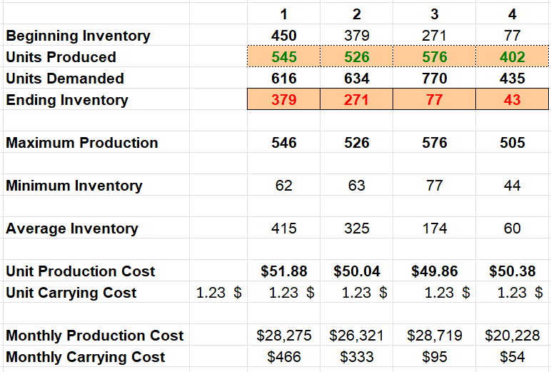*



Model with Stipulation

*Please copy the tab of your original model before continuing with the next part to avoid messing up your original solution. If we remove the production capacity constraint from the model & we removed the carrying cost, what do you think will happen? Try it out and see if it matches your expectation. Try to explain what is happening and talk a bit about fallbacks of models.*

*What I observed was that the total cost actually reduced. By eliminating one of my constraints, my overall results were affected. My 2nd 3rd and 4th month results changed.*

**